**IST 659 – Data Admin Concepts & Database Management**

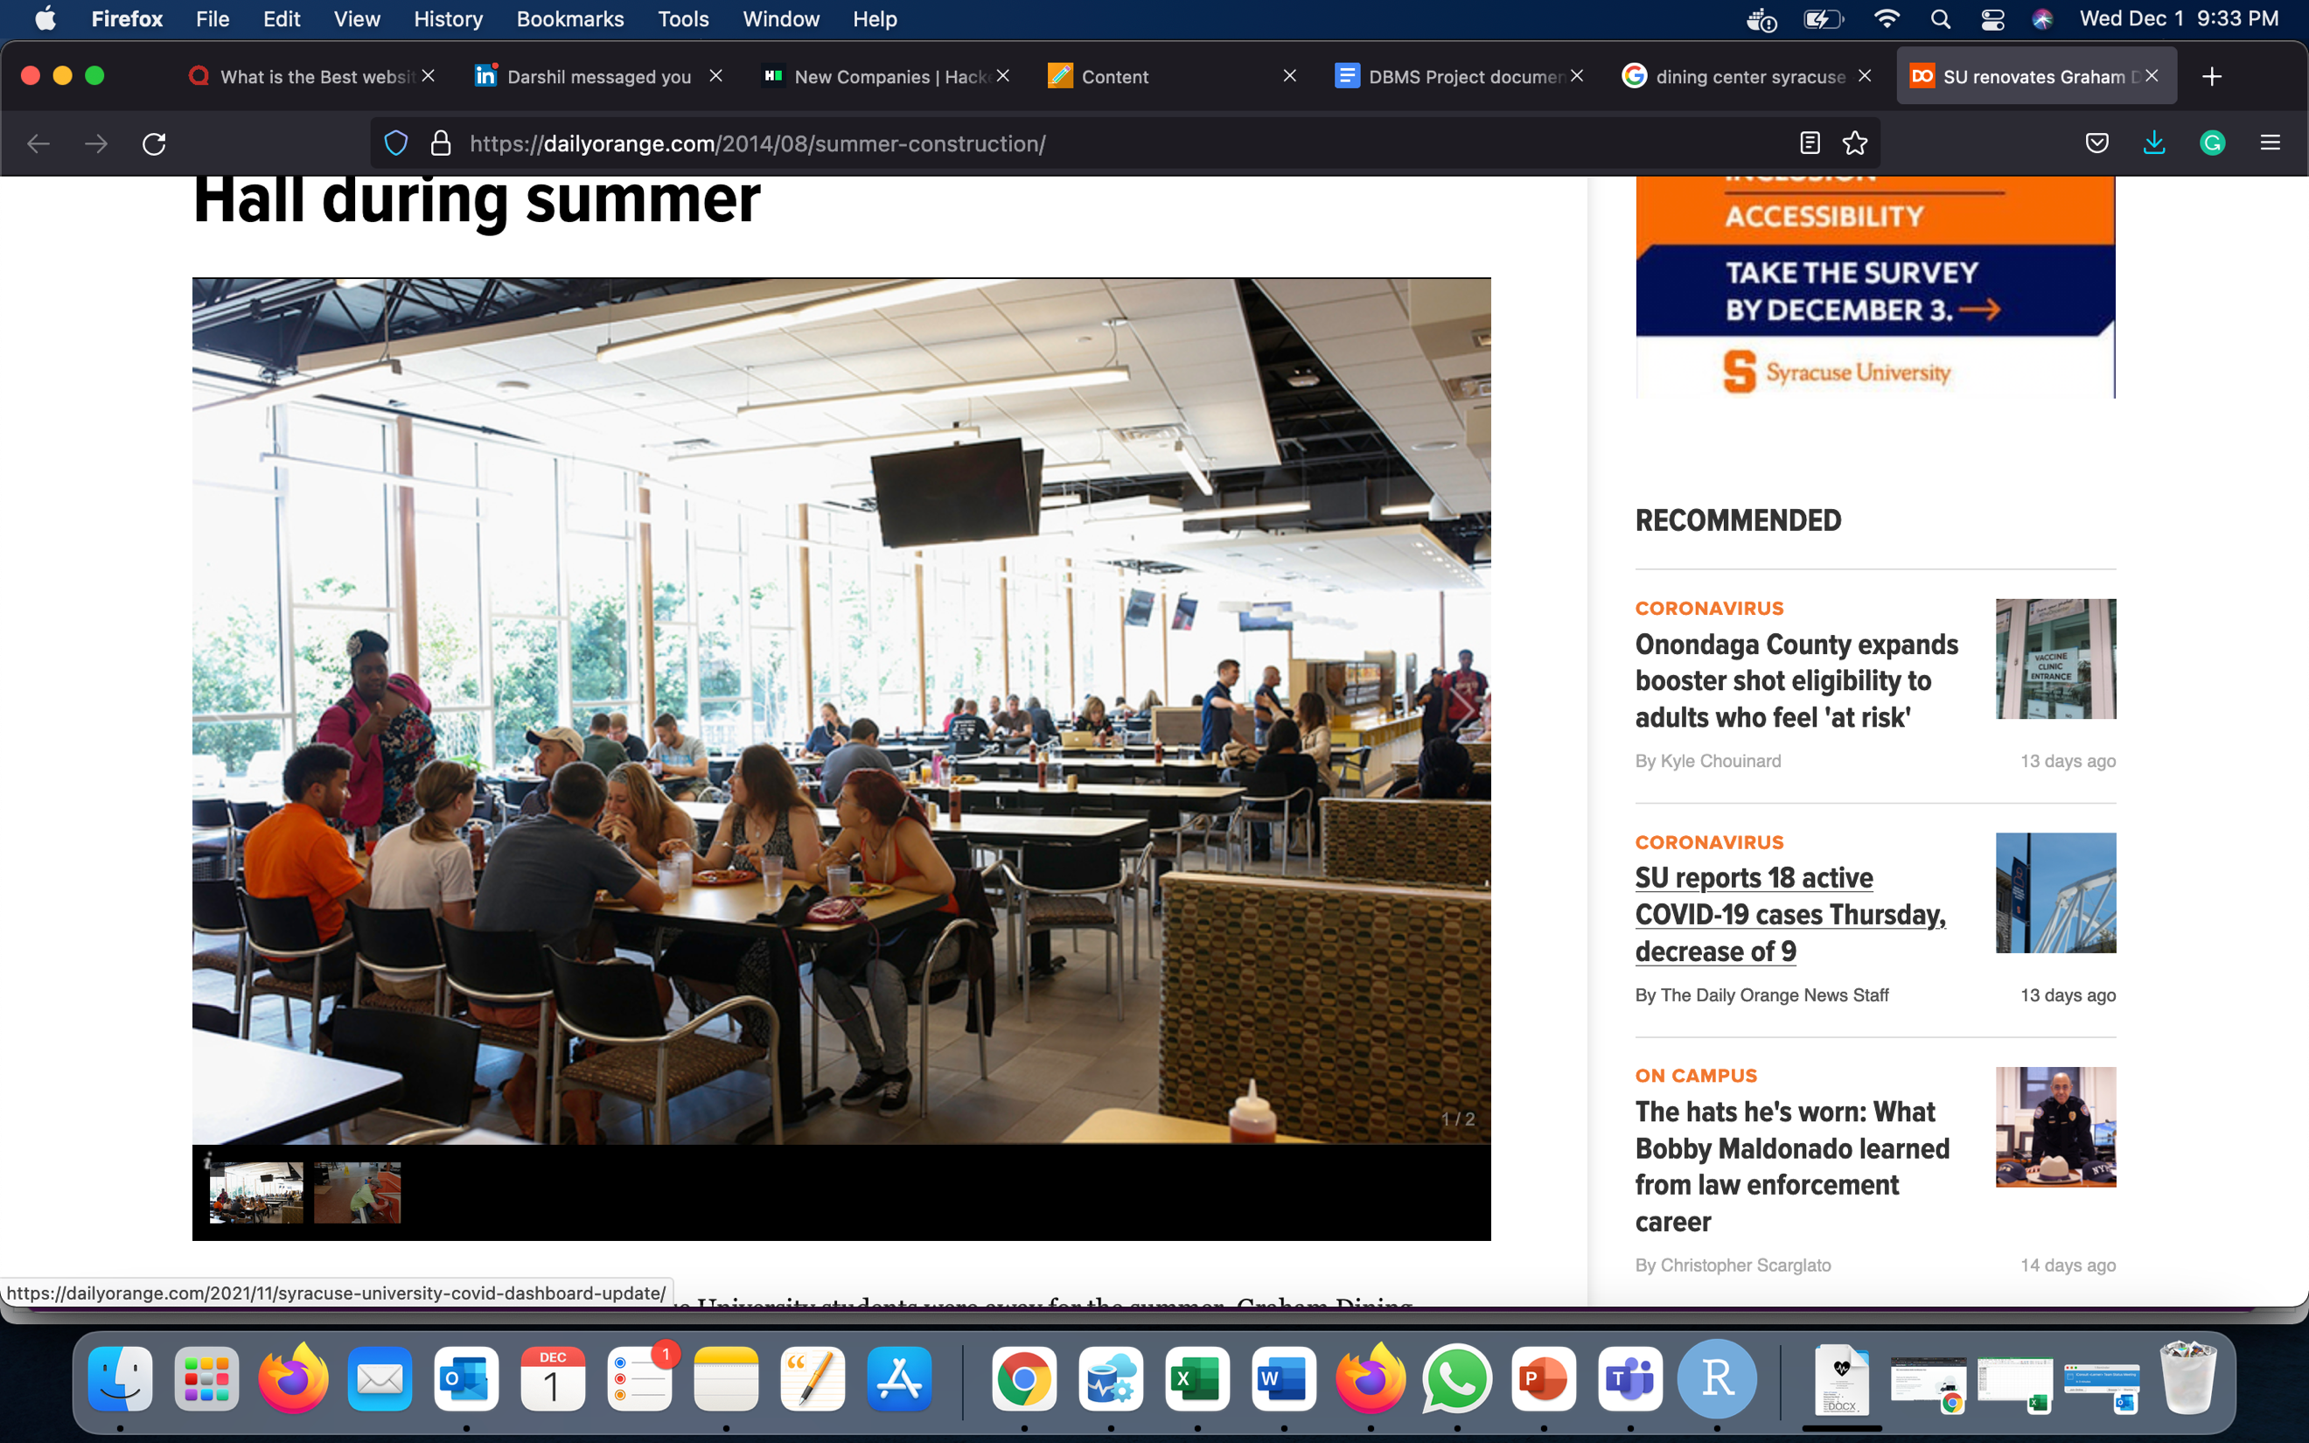

**Project Implementation Report**

**Student Employee Schedule Management System**

**IST 659 M005 Fall 2021**

***Ankita Jayprakash Vartak***

***Manoj Venkatesun Manoharan***

***Nivesh Vasant Vaze***

**Table of Contents**

1. Project Summary**1**
   1. Problem
   2. Solution
2. Conceptual Data Model**2**
3. Logical Data Model**3**
4. Data Dictionary**9**
5. Business Rules**10**
6. Database System Infrastructure**10**
7. SQL Codes**20**
8. Major Data Questions**24**
9. Interface Implementation-Forms and Reports**26**
10. PPT Presentation**33**
11. Deliverables**40**
12. **PROJECT SUMMARY**
    1. **PROBLEM**

At Syracuse University, we have students working as a part-time employee at SU Food services dining centers like Sadler Dining Hall, Ernie Davis Dining Hall, Graham Dining Hall, Shaw Dining Hall, Brockway Dining Hall, etc. All these dining centers are using MS Excel for maintaining student data and scheduling shifts. There are loads of files in the dining office, which is tedious to manage. Each day they print the schedule for the student working on a particular workstation. Handwritten tables and excel sheets are still the go-to methods. In this case, how to manage workforce allotment is an inevitable problem. Failure to maintain data systems can easily lead to information loss or confusion between Managers, Supervisors, and students. It becomes difficult for Managers to keep a record of student emails and schedule shifts for them. Scheduling data is gathered from multiple places and managers, which becomes confusing. A student needs to allocate his shift through mailing which creates constraints that are managed by managers and supervisors. It is difficult for students as well as supervisors to schedule a time and allocate workstations each time.

* 1. **SOLUTION**

To improve this ongoing issue, we have implemented a model for the Syracuse University Dining Centers which will handle the scheduling part. We will be scheduling shifts with the help of Application using Power Apps that can maintain the records of student employee in a particular dining workspace.

1. **CONCEPTUAL DATA MODEL**

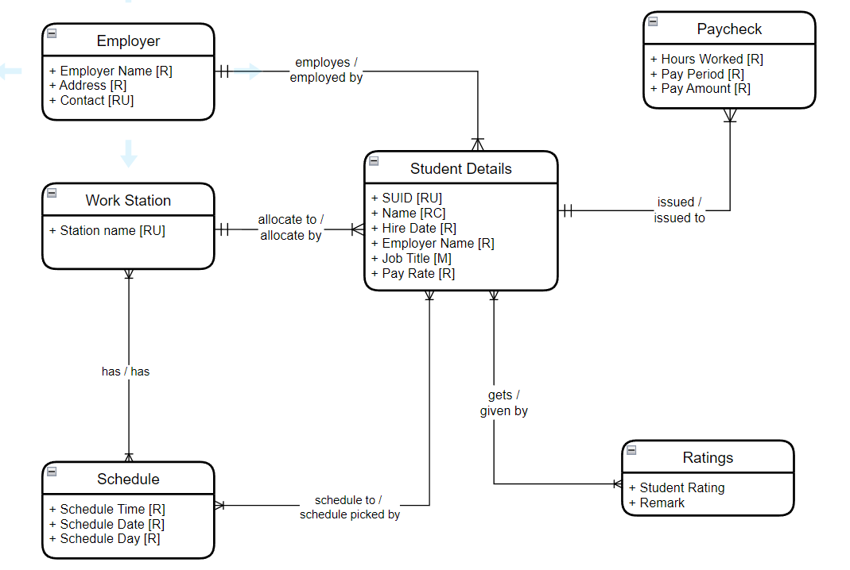

1. **LOGICAL DATA MODEL**

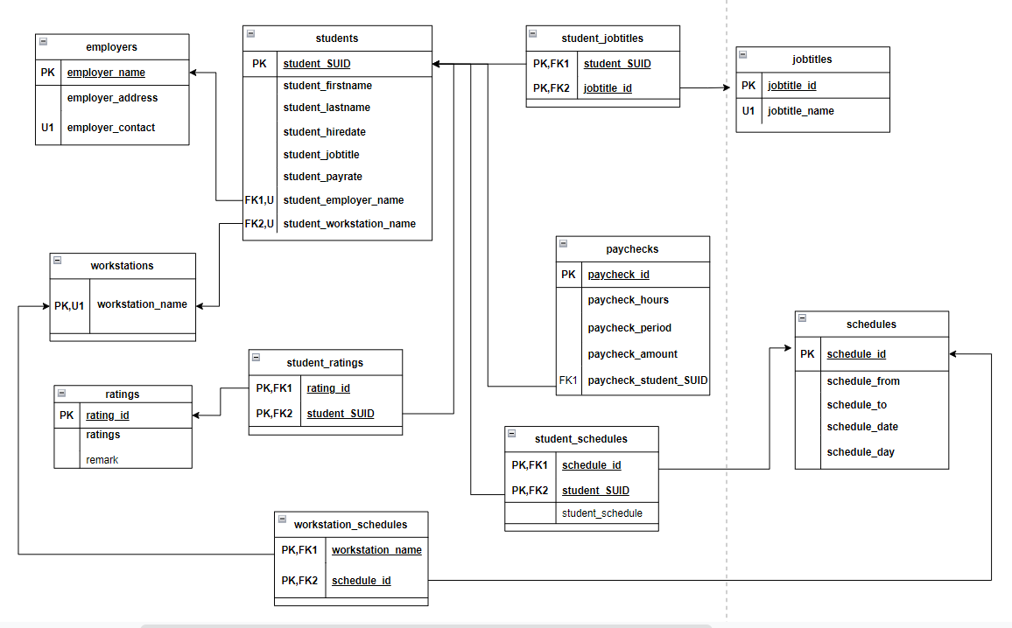

1. **DATA DICTIONARY**

**1) Students:**

**Details of student employee working at the dining centers in Syracuse University**

​​

|  |  |  |  |  |  |
| --- | --- | --- | --- | --- | --- |
| Entity Name: students | Entity and Attributes | Field Type | Nullable | Foreign key constraints | Description |
| Primary Key | student_SUID | Int | Not Null |  | The unique number of student IDs |
|  | student_firstname | Varchar (50) | Not Null |  | First name of student |
|  | student_lastname | Varchar (50) | Not Null |  | Last name of student |
|  | student_hiredate | date | Not Null |  | Date the student was hired |
|  | student_jobtitle | Varchar (100) | Not Null |  | Student Designation |
|  | student_payrate | int | Not Null |  | Designated pay for that post |
| Foreign Key | student_employer_name | Varchar (50) | Not Null | Table Employer  (employer_name) | ID for dining center |
| Foreign Key | student_workstation_name | Varchar (50) | Not Null | Table Workstation  (workstation_name) | ID for workstation |

 ​

**2) Employers:**

**Details of different dining centers at Syracuse University**

|  |  |  |  |  |
| --- | --- | --- | --- | --- |
| Entity Name:  Employers | Entity and Attributes | Field Type | Nullable | Description |
| Primary Key | employer_name | Varchar (50) | Not Null | Name of Dining center |
|  | employer_address | Varchar (50) | Not Null | The address of Dining center |
| Unique Key | employer_contact | Int | Not Null | Contact details of Dining center |

**3) Workstations:**

**Different workstation in dining centers at Syracuse University**

|  |  |  |  |  |
| --- | --- | --- | --- | --- |
| Entity Name:  Workstations | Entity and Attributes | Field Type | Nullable | Description |
| Primary Key,  Unique key | workstation_name | Varchar (50) | Not Null | Specific Name of Workstation  (Vegan, Deli etc.) |

**4) Schedules:**

**Schedules of the day available to work at dining centers**

|  |  |  |  |  |
| --- | --- | --- | --- | --- |
| Entity Name:  Schedules | Entity and Attributes | Field Type | Nullable | Description |
| Primary Key | schedule_id | Int | Not Null | Specific ID |
|  | schedule_from | Time | Not Null | Specific scheduled from |
|  | schedule_to | Time | Not Null | Specific scheduled to |
|  | schedule_date | Daytime | Not Null | Specific scheduled date |
|  | schedule_day | Day | Not Null | Specific scheduled day |

**5) Paychecks:**

**Paycheck details of a student working at dining centers**

|  |  |  |  |  |  |
| --- | --- | --- | --- | --- | --- |
| Entity Name:  Paychecks | Entity and Attributes | Field Type | Nullable | Foreign Key Constraint | Description |
| Primary Key | paycheck_id | Int | Not Null |  | Specific Paycheck ID |
| Foreign Key | paycheck_student_SUID | Int | Not Null | Table students  (student_SUID) | Student paycheck ID |
|  | paycheck_hours | Int | Not Null |  | Number of hours worked |
|  | paycheck_period | Date Time | Not Null |  | Date and Time worked |
|  | paycheck_amount | Int | Not Null |  | Salary |

**6) Ratings:**

**Rating details of a student employee at dining centers**

|  |  |  |  |  |  |
| --- | --- | --- | --- | --- | --- |
| Entity Name:  Ratings | Entity and Attributes | Field Type | Nullable | Foreign Key Constraint | Description |
| Primary Key | rating_id | Int | Not Null |  | Student rating id |
|  | ratings | Varchar (50) | Null |  | Student rating |
|  | remark | Varchar (50) | Null |  | Reason for Rating |

**7) Jobtitles:**

**Jobtitle details of a student employee at dining centers**

|  |  |  |  |  |  |
| --- | --- | --- | --- | --- | --- |
| Entity Name:  Jobtitles | Entity and Attributes | Field Type | Nullable | Foreign Key Constraint | Description |
| Primary Key | jobtitle_id | Int | Not Null |  | Jobtitle id |
| Unique Key | Jobtitle_name | Varchar (50) | Not Null |  | Jobtitle name |

**8) Student Schedules:**

**Work schedule details of a student employee at dining centers**

|  |  |  |  |  |  |
| --- | --- | --- | --- | --- | --- |
| Entity Name:  Student schedules | Entity and Attributes | Field Type | Nullable | Foreign Key Constraint | Description |
| Primary Key,  Foreign Key | schedule_id | Int | Not Null | Table schedules  (schedule_id) | Schedule id |
| Primary Key,  Foreign Key | student_SUID | Int | Not Null | Table students  (student_SUID) | Student SUID |
|  | student_schedule | Varchar (50) | Null |  | Additional comments |

**9) Workstation schedules:**

**Workstation details of a student employee at dining centers**

|  |  |  |  |  |  |
| --- | --- | --- | --- | --- | --- |
| Entity Name:  Workstation schedules | Entity and Attributes | Field Type | Nullable | Foreign Key Constraint | Description |
| Primary Key,  Foreign Key | workstation_name | Varchar (50) | Not Null | Table workstations  (workstation_name) | Name of Workstation |
| Primary Key,  Foreign Key | schedule_id | Int | Not Null | Table schedules  (schedule_id) | Schedule id |

**10) Student Jobtitles:**

**Job titles of a student employee at dining centers**

|  |  |  |  |  |  |
| --- | --- | --- | --- | --- | --- |
| Entity Name:  Student Jobtitles | Entity and Attributes | Field Type | Nullable | Foreign Key Constraint | Description |
| Primary Key,  Foreign Key | Student_SUID | Int | Not Null | Table students  (Student_SUID) | Student SUID |
| Primary Key,  Foreign Key | jobtitle_id | Int | Not Null | Table jobtitles  (jobtitle_id) | Jobtitle id |

**11) Student Ratings:**

**Ratings of a student employee at dining centers**

|  |  |  |  |  |  |
| --- | --- | --- | --- | --- | --- |
| Entity Name:  Student Ratings | Entity and Attributes | Field Type | Nullable | Foreign Key Constraint | Description |
| Primary Key,  Foreign Key | rating_id | Int | Not Null | Table ratings  (rating_id) | Rating id |
| Primary Key,  Foreign Key | Student_SUID | Int | Not Null | Table students  (Student_SUID) | Student SUID |

1. **Business Rules**

* The application is developed for the use of Supervisor to add/remove employees, assign workstations, and give ratings to the employees and generate paycheck for hours worked by student employees.
* One student can be employed by one and only one employer at a given time.
* A general employee can work at one workstation at a time
* Only one employee can be assigned a particular workstation at a time
* A student can pick multiple schedules
* A schedule can be assigned to multiple students
* Pay amount is entered manually by supervisor after the shift is completed on a regular basis
* Paycheck is generated weekly by student manager to aggregate the daily pay amount

1. **Database system Infrastructure**

We used the following tools to create and implement this project:

1. **Draw.io:**

We created an entity-relationship diagram using draw.io We also created logical diagram and defined the attributes with the keys (primary & foreign). We built the relationships between entities.

1. **Azure Data Studio:**

We used Azure Data Studio as the database tool to store all the tables and data. We populated tables in the database using SQL queries.

1. **MS PowerApps:**

We used MS PowerApps to create the interface for the system. We linked our tables present in SQL Server with the screen and forms configured on PowerApps, to take user input and display the required data.

1. **SQL Code**

Creating Tables and Inserting Sample Data



use ist659ajvartak

go

Drop table if exists students

go

Create Table students(

   student_SUID int NOT NULL,

   student_firstname varchar(50) NOT NULL,

   student_lastname varchar(50) NOT NULL,

   student_hiredate date NOT NULL,

   student_jobtitle varchar(50) NOT NULL,

   student_payrate Int NOT NULL,

   student_employer_name VARCHAR(50) NOT NULL,

   student_workstation_name varchar(50) NOT NULL

   Constraint students_PK Primary Key(student_SUID)

)

ALTER table students

ADD Constraint students_UK UNIQUE (student_employer_name,student_workstation_name)

GO

Drop table if exists employers

   go

Create Table employers (

   employer_name varchar(50) NOT NULL,

   employer_address varchar(25) NOT NULL,

   employer_contact bigint NOT NULL

Constraint employers_PK Primary Key(employer_name),

CONSTRAINT employers_UK UNIQUE (employer_contact)

)

Drop table if exists workstations

  go

Create Table workstations (

workstation_name varchar(50) NOT NULL,

Constraint workstation_PK Primary Key(workstation_name),

Constraint workstation_UK Unique (workstation_name)

)

ALTER table students

ADD Constraint students_FK1 Foreign Key(student_employer_name) References employers(employer_name),

Constraint students_FK2 Foreign Key(student_workstation_name) References workstations(workstation_name)

GO

Drop table if exists schedules

   go

Create Table schedules (

schedule_id int identity,

schedule_from time NOT NULL,

schedule_to time NOT NULL,

schedule_date date NOT NULL,

schedule_day VARCHAR(50) NOT NULL

Constraint schedules_PK Primary Key(schedule_id)

)

--paychecks Table

Drop table if exists paychecks

   go

Create Table paychecks (

paycheck_id int NOT NULL identity,

paycheck_hours int NOT NULL,

paycheck_period datetime default getdate(),

paycheck_amount int NOT NULL,

paycheck_student_SUID int NOT NULL,

paycheck_note VARCHAR(25) NULL

Constraint paychecks_PK Primary Key(paycheck_id)

Constraint paychecks_FK Foreign Key(paycheck_student_SUID) References students(student_SUID)

)

--ratings Table

Drop table if exists ratings

   go

Create Table ratings (

rating_id int NOT NULL identity,

ratings varchar(50),

remark VARCHAR(50)

Constraint ratings_PK Primary Key(rating_id)

)

-- jobtitles Table

Drop table if exists jobtitles

   go

Create table jobtitles (

jobtitle_id int NOT NULL,

jobtitle_name varchar(50) NOT NULL,

Constraint jobtitles_UK Unique(jobtitle_name),

Constraint jobtile_PK Primary Key(jobtitle_id)

)

-- student_schedules Table

Drop table if exists student_schedules

   go

Create Table student_schedules(

schedule_id int NOT NULL,

student_SUID int NOT NULL,

student_schedule VARCHAR(50) Null,

CONSTRAINT student_schedules_PK PRIMARY KEY(schedule_id, student_SUID),

CONSTRAINT student_schedules_FK1 FOREIGN KEY (schedule_id) REFERENCES schedules (schedule_id),

CONSTRAINT student_schedules_FK2 FOREIGN KEY (student_SUID) REFERENCES students (student_SUID)

)

-- student_ratings Table

Drop table if exists student_ratings

go

Create Table student_ratings(

rating_id int NOT NULL IDENTITY,

student_SUID int NOT NULL,

ratings int Not Null,

remark varchar(50),

CONSTRAINT student_ratings_PK PRIMARY KEY(rating_id, student_SUID),

CONSTRAINT student_ratings_FK2 FOREIGN KEY (student_SUID) REFERENCES students (student_SUID)

)

-- student_jobtitles Table

Drop table if exists student_jobtitles

   go

Create Table student_jobtitles(

student_SUID int NOT NULL,

jobtitle_id int NOT NULL,

CONSTRAINT student_jobtitles_PK PRIMARY KEY(student_SUID, jobtitle_id),

CONSTRAINT student_jobtitles_FK1 FOREIGN KEY (jobtitle_id) REFERENCES jobtitles (jobtitle_id),

CONSTRAINT student_jobtitles_FK2 FOREIGN KEY (student_SUID) REFERENCES students (student_SUID)

)

-- workstation_schedules Table

Drop table if exists workstation_schedules

  go

Create Table workstation_schedules(

workstation_name VARCHAR(50) NOT NULL,

schedule_id int NOT NULL,

CONSTRAINT workstation_schedules_PK PRIMARY KEY(workstation_name, schedule_id),

CONSTRAINT workstation_schedules_FK1 FOREIGN KEY (workstation_name) REFERENCES workstations (workstation_name),

CONSTRAINT workstation_schedules_FK2 FOREIGN KEY (schedule_id) REFERENCES schedules (schedule_id)

)

select * from students

select * from employers

select * from workstations

select * from schedules

select * from paychecks

select * from ratings

select * from jobtitles

select * from student_schedules

select * from student_jobtitles

select * from student_ratings

select * from workstation_schedules

INSERT INTO jobtitles VALUES (1, 'General Employee')

INSERT INTO jobtitles VALUES (2, 'Supervisor')

INSERT INTO workstations VALUES ('Deli')

INSERT INTO workstations VALUES ('Hotline')

INSERT INTO workstations VALUES ('Salads')

INSERT INTO workstations VALUES ('Vegan')

INSERT INTO workstations VALUES ('Dishroom')

INSERT INTO workstations VALUES ('Dining Room')

INSERT INTO workstations VALUES ('Express')

INSERT INTO workstations VALUES ('Dessert')

INSERT INTO workstations VALUES ('Beverages')

INSERT INTO workstations VALUES ('Gluten Free')

INSERT INTO employers VALUES ('Sadler Dining', 'Sims Drive Street', 6809108108)

INSERT INTO employers (employer_name, employer_address, employer_contact) VALUES ('Graham Dining','Comstock street',6809108121)

INSERT INTO employers (employer_name, employer_address, employer_contact) VALUES ('Ernie Davis Dining',' University Ave',6803434565)

INSERT INTO employers (employer_name, employer_address, employer_contact) VALUES ('Shaw Dining','Euclid street',6809809977)

INSERT INTO employers (employer_name, employer_address, employer_contact) VALUES ('Brockway Dining',' Van Buren street',6801133242)

INSERT into students values (358554918, 'Ankita',   'Vartak',   '08/30/2021',  'General Employee',15,'Sadler Dining','Deli')

INSERT into students values (660307939, 'Chaitanya','Attarde',  '09/02/2021',  'General Employee',  15,'Sadler Dining', 'Salads')            INSERT into students values (859436780, 'Aishwary', 'Patel', '09/04/2021',  'General Employee',  15,   'Ernie Davis Dining', 'Vegan')        INSERT into students values (812995446, 'Shivani',   'Pol',      '09/01/2021', 'General Employee',  15,   'Graham Dining', 'Salads')         INSERT into students values (955036125, 'Vamsy',   'Krishna',   '08/31/2021',  'Supervisor',       17, 'Ernie Davis Dining', 'Dishroom')     INSERT into students values (411946624, 'Nivesh',   'Vaze',      '09/05/2021', 'General Employee',  15,   'Brockway Dining', 'Hotline')      INSERT into students values (475885683, 'Anushree',  'Keni', '10/03/2021',  'General Employee',  15,   'Shaw Dining', 'Deli')                INSERT into students values (324669421, 'Abhijeet', 'Gokhale',  '08/28/2021',  'Supervisor',      17,  'Sadler Dining', 'Vegan')

INSERT into students values (452175821,

'Nikita', 'Sirwani','09/03/2021', 'General Employee', 15,   'Graham Dining', 'Hotline')

INSERT into students values (458231945, 'Ruzan', 'Shaikh',   '09/15/2021',  'Student Manager',   18,   'Graham Dining', 'Dishroom')

INSERT into schedules values ('09:00:00','13:00:00', '2021-11-22', 'Monday')

INSERT into schedules values ('13:00:00','17:00:00', '2021-11-22', 'Monday')

INSERT into schedules values ('17:00:00','21:00:00', '2021-11-22', 'Monday')

INSERT into schedules values ('09:00:00','13:00:00', '2021-11-23', 'Tuesday')

INSERT into schedules values ('13:00:00','17:00:00', '2021-11-23', 'Tuesday')

INSERT into schedules values ('17:00:00','21:00:00', '2021-11-23', 'Tuesday')

INSERT into schedules values ('09:00:00','13:00:00', '2021-11-24', 'Wednesday')

INSERT into schedules values ('13:00:00','17:00:00', '2021-11-24', 'Wednesday')

INSERT into schedules values ('17:00:00','21:00:00', '2021-11-24', 'Wednesday')

INSERT into schedules values ('09:00:00','13:00:00', '2021-11-25', 'Thursday')

INSERT into schedules values ('13:00:00','17:00:00', '2021-11-25', 'Thursday')

INSERT into schedules values ('17:00:00','21:00:00', '2021-11-25', 'Thursday')

INSERT into schedules values ('09:00:00','13:00:00', '2021-11-26', 'Friday')

INSERT into schedules values ('13:00:00','17:00:00', '2021-11-26', 'Friday')

INSERT into schedules values ('17:00:00','21:00:00', '2021-11-26', 'Friday')

INSERT into schedules values ('09:00:00','13:00:00', '2021-11-27', 'Saturday')

INSERT into schedules values ('13:00:00','17:00:00', '2021-11-27', 'Saturday')

INSERT into schedules values ('17:00:00','21:00:00', '2021-11-27', 'Saturday')

INSERT into schedules values ('09:00:00','13:00:00', '2021-11-28', 'Sunday')

INSERT into schedules values ('13:00:00','17:00:00', '2021-11-28', 'Sunday')

INSERT into schedules values ('17:00:00','21:00:00', '2021-11-28', 'Sunday')

INSERT into workstation_schedules values('Deli',1)

select * from workstation_schedules

/*select * from students s

join workstations w on s.student_workstation_ID = w.workstation_id

join workstation_schedules ws on w.workstation_id = ws.workstation_id

join schedules ss on ws.schedule_id = ss.schedule_id where student_employer_ID=1;*/

INSERT into student_schedules VALUES (1,358554918, 'Ankita_shift')

INSERT into student_schedules VALUES (2,458231945, 'Ruz shift')

Insert into student_ratings VALUES (358554918, 4, 'By Abhijeet')

INSERT into paychecks(paycheck_hours, paycheck_amount, paycheck_student_SUID, paycheck_note) VALUES(4, 60, 358554918, 'abhijeet paycheck');

--Drop Views(list of schedules) if exist

if exists (select * from sys.objects where name='Sadler Schedule')

   drop view [Sadler Schedule]

if exists (select * from sys.objects where name='Graham Schedule')

   drop view [Graham Schedule]

if exists (select * from sys.objects where name='Ernie Davis Schedule')

   drop view [Ernie Davis Schedule]

if exists (select * from sys.objects where name='Shaw Schedule')

   drop view [Shaw Schedule]

if exists (select * from sys.objects where name='Brockway Schedule')

   drop view [Brockway Schedule]

--Drop Views (list of employee) if exist

if exists (select * from sys.objects where name='Sadler Students')

   drop view [Sadler Students]

if exists (select * from sys.objects where name='Graham Students')

   drop view [Graham Students]

if exists (select * from sys.objects where name='Ernie Davis Students')

   drop view [Ernie Davis Students]

if exists (select * from sys.objects where name='Shaw Students')

   drop view [Shaw Students]

if exists (select * from sys.objects where name='Brockway Students')

   drop view [Brockway Students]

CREATE VIEW [Sadler Schedule] AS

select s.student_SUID, s.student_firstname +' '+s.student_lastname as student_name, s.student_jobtitle, e.employer_name, w.workstation_name, sc.schedule_from, sc.schedule_to, schedule_date, sc.schedule_day

from students s

join employers e on s.student_employer_name = e.employer_name

join workstations w on s. student_workstation_name = w.workstation_name

join student_schedules ss on s.student_SUID = ss.student_SUID

join schedules sc on ss.schedule_id = sc.schedule_id

where e.employer_name='Sadler Dining';

CREATE VIEW [Graham Schedule] AS

select s.student_SUID, s.student_firstname +' '+s.student_lastname as student_name, s.student_jobtitle, e.employer_name, w.workstation_name, sc.schedule_from, sc.schedule_to, schedule_date, sc.schedule_day

from students s

join employers e on s.student_employer_name = e.employer_name

join workstations w on s.student_workstation_name = w.workstation_name

join student_schedules ss on s.student_SUID = ss.student_SUID

join schedules sc on ss.schedule_id = sc.schedule_id

where e.employer_name='Graham Dining';

CREATE VIEW [Ernie Davis Schedule] AS

select s.student_SUID, s.student_firstname +' '+s.student_lastname as student_name, s.student_jobtitle, e.employer_name, w.workstation_name, sc.schedule_from, sc.schedule_to, schedule_date, sc.schedule_day

from students s

join employers e on s.student_employer_name = e.employer_name

join workstations w on s.student_workstation_name = w.workstation_name

join student_schedules ss on s.student_SUID = ss.student_SUID

join schedules sc on ss.schedule_id = sc.schedule_id

where e.employer_name='Ernie Davis Dining';

CREATE VIEW [Shaw Schedule] AS

select s.student_SUID, s.student_firstname +' '+s.student_lastname as student_name, s.student_jobtitle, e.employer_name, w.workstation_name, sc.schedule_from, sc.schedule_to, schedule_date, sc.schedule_day

from students s

join employers e on s.student_employer_name = e.employer_name

join workstations w on s.student_workstation_name = w.workstation_name

join student_schedules ss on s.student_SUID = ss.student_SUID

join schedules sc on ss.schedule_id = sc.schedule_id

where e.employer_name='Shaw Dining';

CREATE VIEW [Brockway Schedule] AS

select s.student_SUID, s.student_firstname +' '+s.student_lastname as student_name, s.student_jobtitle, e.employer_name, w.workstation_name, sc.schedule_from, sc.schedule_to, schedule_date, sc.schedule_day

from students s

join employers e on s.student_employer_name = e.employer_name

join workstations w on s.student_workstation_name = w.workstation_name

join student_schedules ss on s.student_SUID = ss.student_SUID

join schedules sc on ss.schedule_id = sc.schedule_id

where e.employer_name='Brockway Dining';

--View for list of employees at specific dining

CREATE VIEW [Sadler Students] AS

select * from students

join employers on student_employer_name = employer_name

where employer_name='Sadler Dining';

CREATE VIEW [Graham Students] AS

select * from students

join employers on student_employer_name = employer_name

where employer_name='Graham Dining';

CREATE VIEW [Ernie Davis Students] AS

select * from students

join employers on student_employer_name = employer_name

where employer_name='Ernie Davis Dining';

CREATE VIEW [Shaw Students] AS

select * from students

join employers on student_employer_name = employer_name

where employer_name='Shaw Dining';

CREATE VIEW [Brockway Students] AS

select * from students

join employers on student_employer_name = employer_name

where employer_name='Brockway Dining';

----------Create View for rating----

Create view [V1_Student Ratings] AS

select sr.student_SUID, student_firstname,student_lastname, ratings, remark from students s

join student_ratings sr

on s.student_SUID = sr.student_SUID;

select * from [Sadler Students]

select * from [Graham students]

select * from [Ernie Davis students]

select * from [Shaw Students]

select * from [Brockway Students]

----Query to fetch all details of a single student----

select s.student_SUID, s.student_firstname +' '+ s.student_lastname as [Employee Name], s.student_employer_name, s.student_workstation_name, sc.schedule_day, sc.schedule_date, sc.schedule_from, sc.schedule_to   from students s

join student_schedules ss on s.student_SUID = ss.student_SUID

join schedules sc on ss.schedule_id = sc.schedule_id

where s.student_SUID = '358554918';

--Paycheck details--

Create view [Paycheck Data] AS

select student_firstname+' '+student_lastname as[Student Name],student_employer_name, paycheck_student_SUID, sum(paycheck_amount) as [Total paycheck amount] from paychecks

join students on paycheck_student_SUID = student_SUID

group by paycheck_student_SUID, student_firstname, student_lastname, student_employer_name;

--View the average rating of an employee--

Create View [Average Rating View] AS

select s.student_firstname+' '+s.student_lastname as [Student Name], s.student_SUID, AVG(ratings) as [Average Rating], s.student_employer_name from student_ratings sr

join students s on s.student_SUID = sr.student_SUID

group by sr.student_SUID, student_firstname, student_lastname, s.student_SUID, s.student_employer_name;

1. **Major Questions**

Answering major data questions that can be solved using the database. The following are the main data questions that can be solved using the database: -

1. **How many students are employed at any dining center at a given point?**

--Total students at Sadler Dining--

CREATE VIEW [Sadler Students] AS

select * from students

join employers on student_employer_name = employer_name

where employer_name='Sadler Dining';

--Total students at Graham Dining--

CREATE VIEW [Graham Students] AS

select * from students

join employers on student_employer_name = employer_name

where employer_name='Graham Dining';

--Total students at Ernie Davis Dining--

CREATE VIEW [Ernie Davis Students] AS

select * from students

join employers on student_employer_name = employer_name

where employer_name='Ernie Davis Dining';

--Total students at Shaw Dining--

CREATE VIEW [Shaw Students] AS

select * from students

join employers on student_employer_name = employer_name

where employer_name='Shaw Dining';

--Total students at Brockway Dining--

CREATE VIEW [Brockway Students] AS

select * from students

join employers on student_employer_name = employer_name

where employer_name='Brockway Dining';

1. **What is the current schedule of any dining center?**

--Current schedule of Sadler Dining--

CREATE VIEW [Sadler Schedule] AS

select s.student_SUID, s.student_firstname +' '+s.student_lastname as student_name, s.student_jobtitle, e.employer_name, w.workstation_name, sc.schedule_from, sc.schedule_to, schedule_date, sc.schedule_day

from students s

join employers e on s.student_employer_name = e.employer_name

join workstations w on s.student_workstation_name = w.workstation_name

join student_schedules ss on s.student_SUID = ss.student_SUID

join schedules sc on ss.schedule_id = sc.schedule_id

where e.employer_name='Sadler Dining';

--Current schedule of Graham Dining--

CREATE VIEW [Graham Schedule] AS

select s.student_SUID, s.student_firstname +' '+s.student_lastname as student_name, s.student_jobtitle, e.employer_name, w.workstation_name, sc.schedule_from, sc.schedule_to, schedule_date, sc.schedule_day

from students s

join employers e on s.student_employer_name = e.employer_name

join workstations w on s.student_workstation_name = w.workstation_name

join student_schedules ss on s.student_SUID = ss.student_SUID

join schedules sc on ss.schedule_id = sc.schedule_id

where e.employer_name='Graham Dining';

--Current schedule of Ernie Davis Dining--

CREATE VIEW [Ernie Davis Schedule] AS

select s.student_SUID, s.student_firstname +' '+s.student_lastname as student_name, s.student_jobtitle, e.employer_name, w.workstation_name, sc.schedule_from, sc.schedule_to, schedule_date, sc.schedule_day

from students s

join employers e on s.student_employer_name = e.employer_name

join workstations w on s.student_workstation_name = w.workstation_name

join student_schedules ss on s.student_SUID = ss.student_SUID

join schedules sc on ss.schedule_id = sc.schedule_id

where e.employer_name='Ernie Davis Dining';

--Current schedule of Shaw Dining Dining--

CREATE VIEW [Shaw Schedule] AS

select s.student_SUID, s.student_firstname +' '+s.student_lastname as student_name, s.student_jobtitle, e.employer_name, w.workstation_name, sc.schedule_from, sc.schedule_to, schedule_date, sc.schedule_day

from students s

join employers e on s.student_employer_name = e.employer_name

join workstations w on s.student_workstation_name = w.workstation_name

join student_schedules ss on s.student_SUID = ss.student_SUID

join schedules sc on ss.schedule_id = sc.schedule_id

where e.employer_name='Shaw Dining';

--Current schedule of Brockway Dining--

CREATE VIEW [Brockway Schedule] AS

select s.student_SUID, s.student_firstname +' '+s.student_lastname as student_name, s.student_jobtitle, e.employer_name, w.workstation_name, sc.schedule_from, sc.schedule_to, schedule_date, sc.schedule_day

from students s

join employers e on s.student_employer_name = e.employer_name

join workstations w on s.student_workstation_name = w.workstation_name

join student_schedules ss on s.student_SUID = ss.student_SUID

join schedules sc on ss.schedule_id = sc.schedule_id

where e.employer_name='Brockway Dining';

1. **Where is a specific employee currently working? (Display the name, employer, workstation and schedule) ex. Where is Ankita working currently?**

select s.student_SUID, s.student_firstname +' '+ s.student_lastname as [Employee Name], s.student_employer_name, s.student_workstation_name, sc.schedule_day, sc.schedule_date, sc.schedule_from, sc.schedule_to   from students s

join student_schedules ss on s.student_SUID = ss.student_SUID

join schedules sc on ss.schedule_id = sc.schedule_id

where s.student_SUID = '358554918';

1. **How can a student manager view the paycheck of a student employee?**

--Paycheck details--

Create view [Paycheck Data] AS

select student_firstname+' '+student_lastname as[Student Name],student_employer_name, paycheck_student_SUID, sum(paycheck_amount) as [Total paycheck amount] from paychecks

join students on paycheck_student_SUID = student_SUID

group by paycheck_student_SUID, student_firstname, student_lastname, student_employer_name;

1. **How can a student manager view the rating and remark given by supervisor to an employee?**

--View the average rating of an employee--

Create View [Average Rating View] AS

select s.student_firstname+' '+s.student_lastname as [Student Name], s.student_SUID, AVG(ratings) as [Average Rating] from student_ratings sr

join students s on s.student_SUID = sr.student_SUID

group by sr.student_SUID, student_firstname, student_lastname, s.student_SUID;

1. **Interface Implementation**

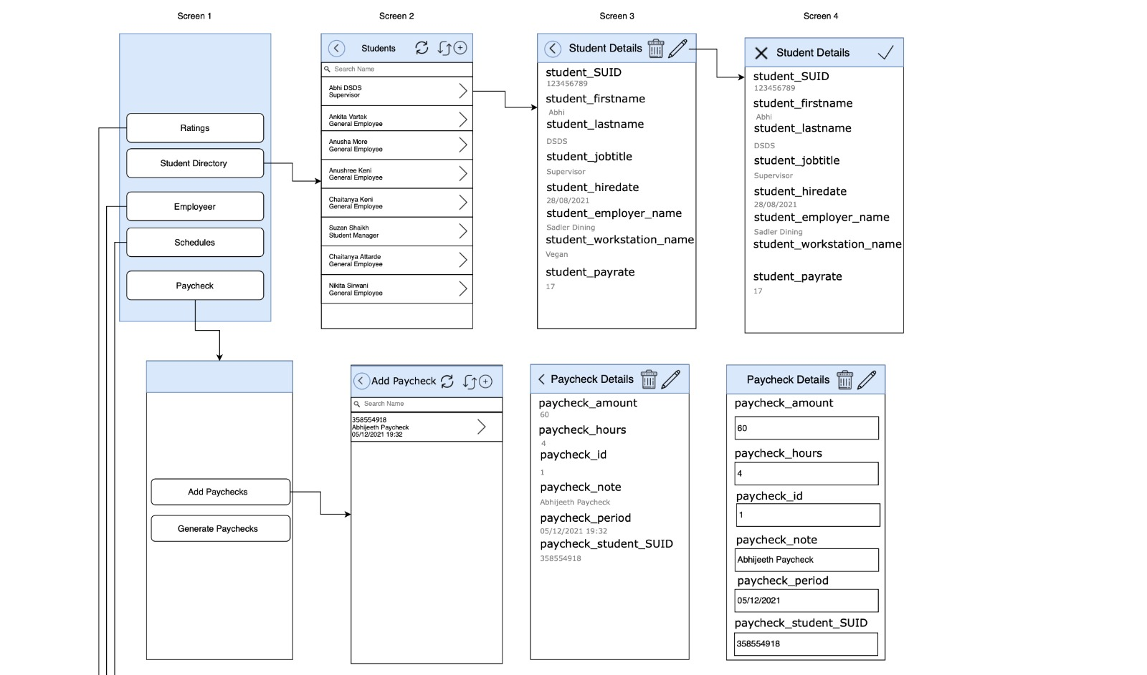

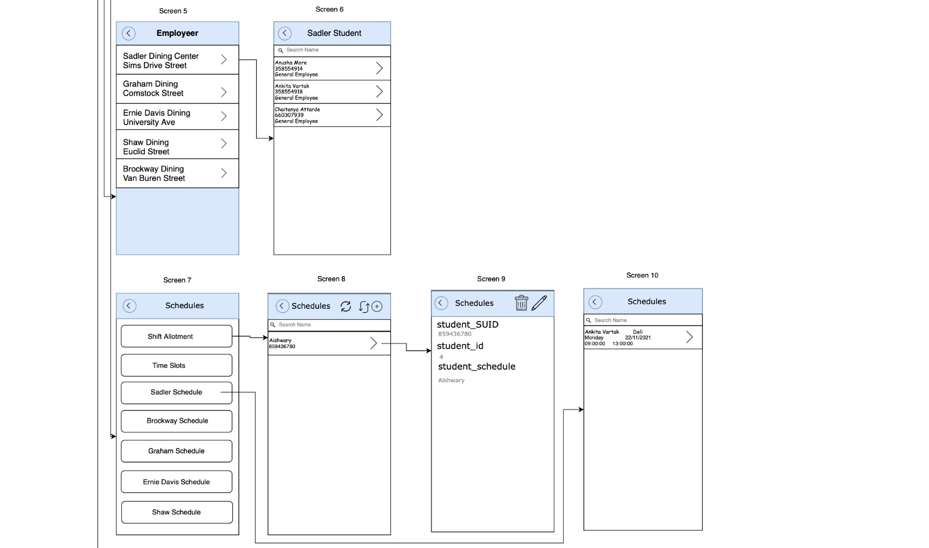

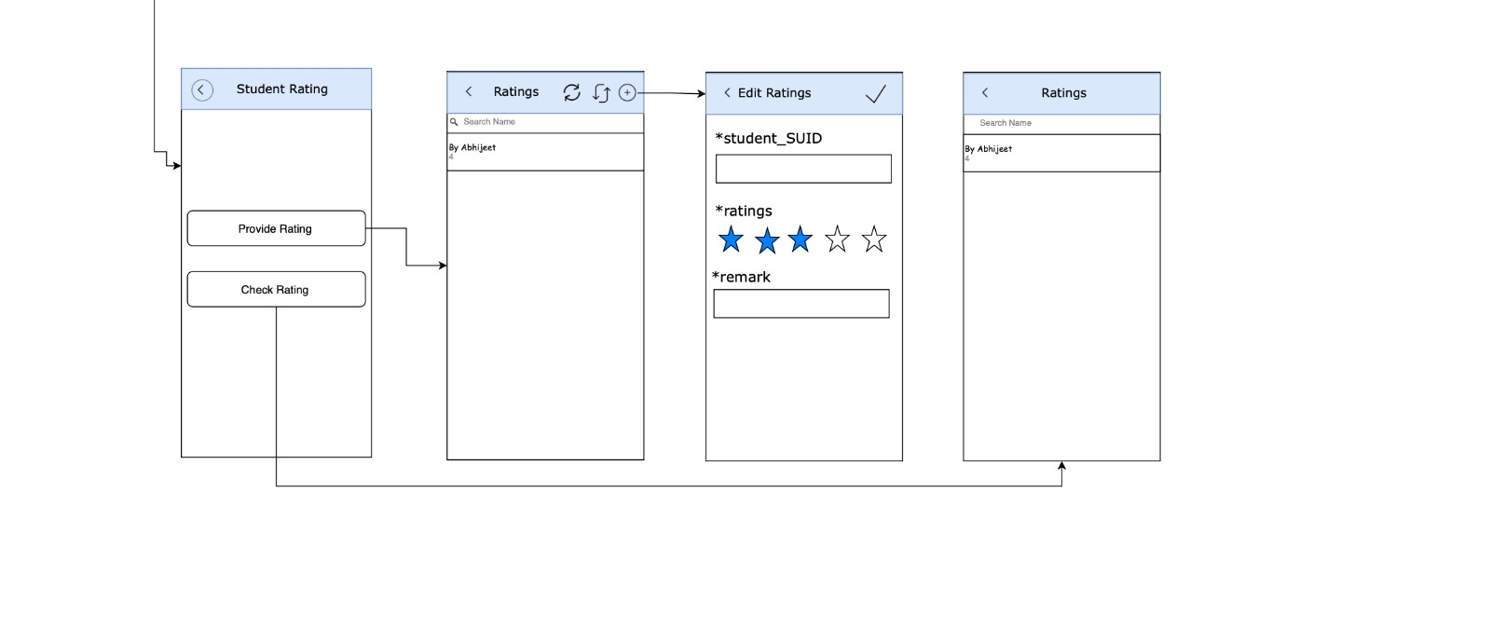

1. **PPT Presentation**

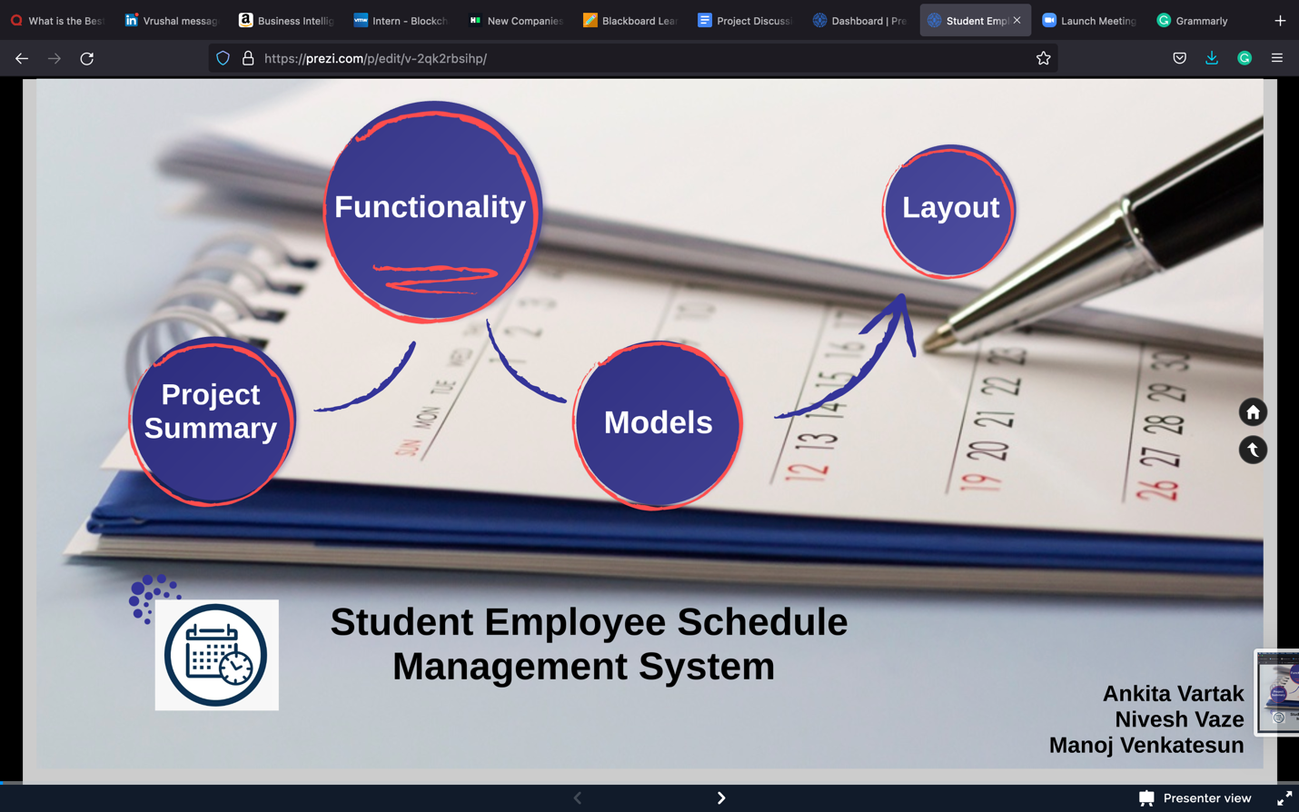

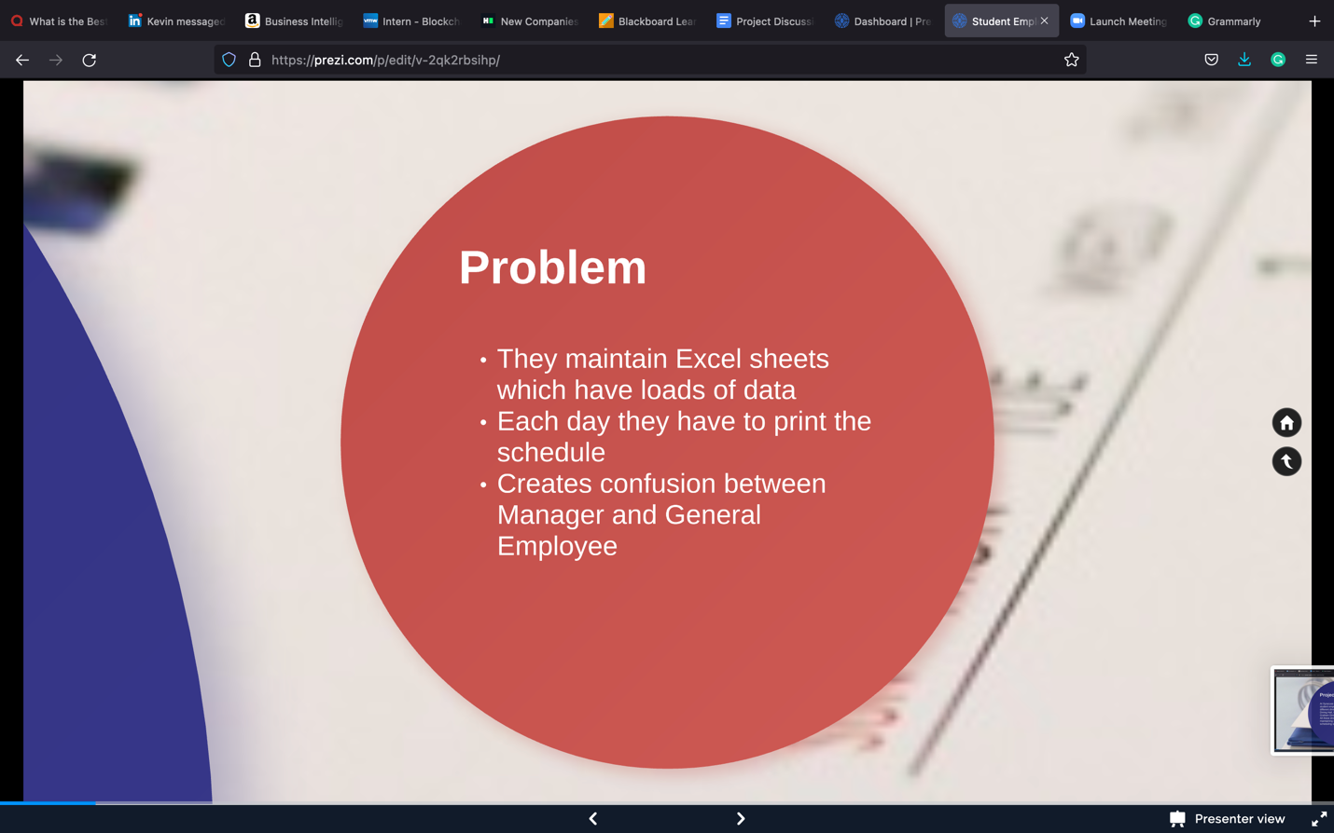

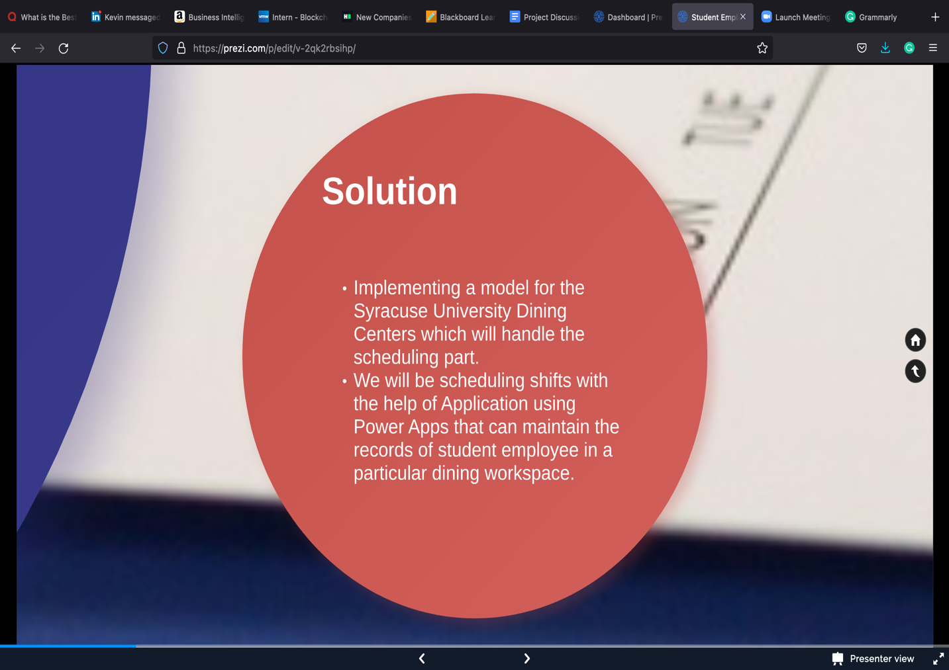

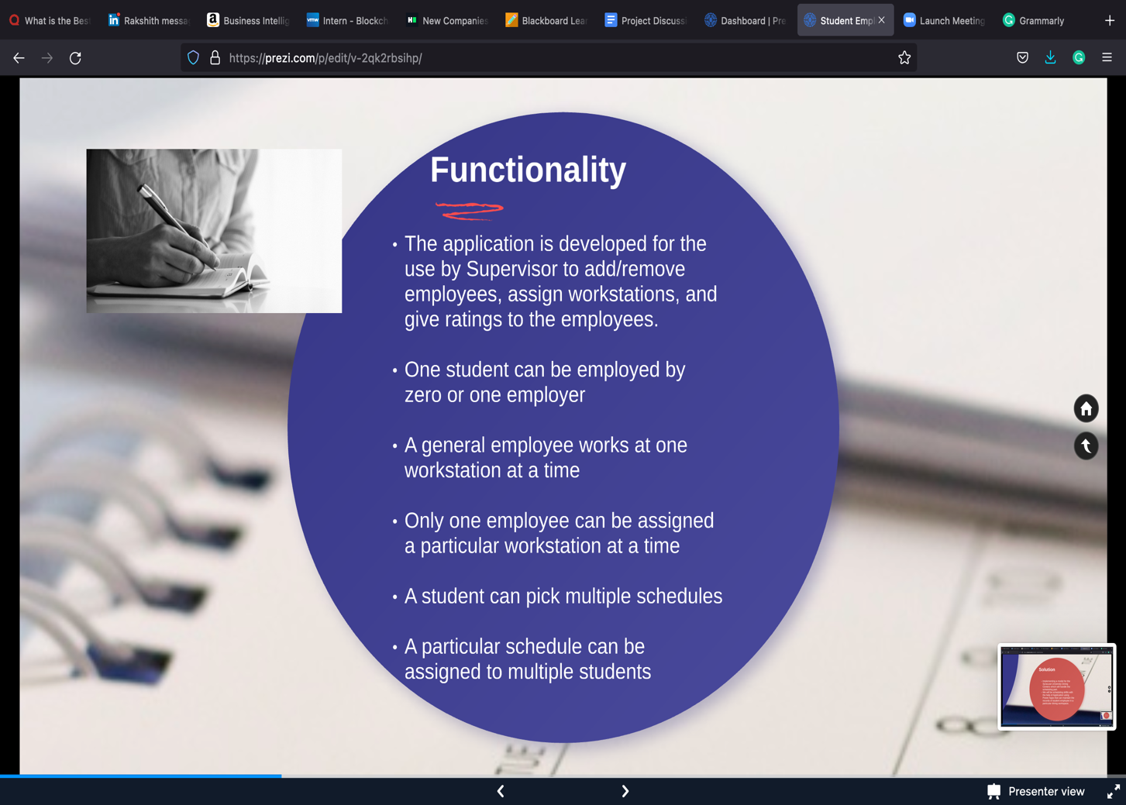

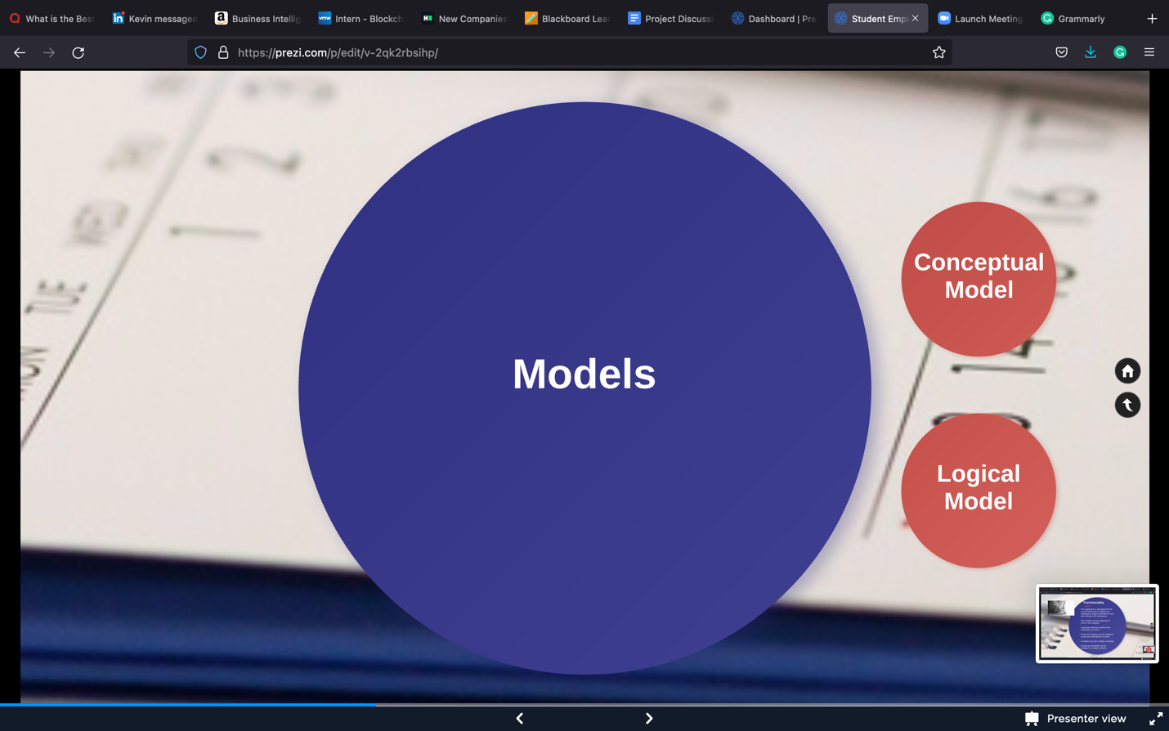

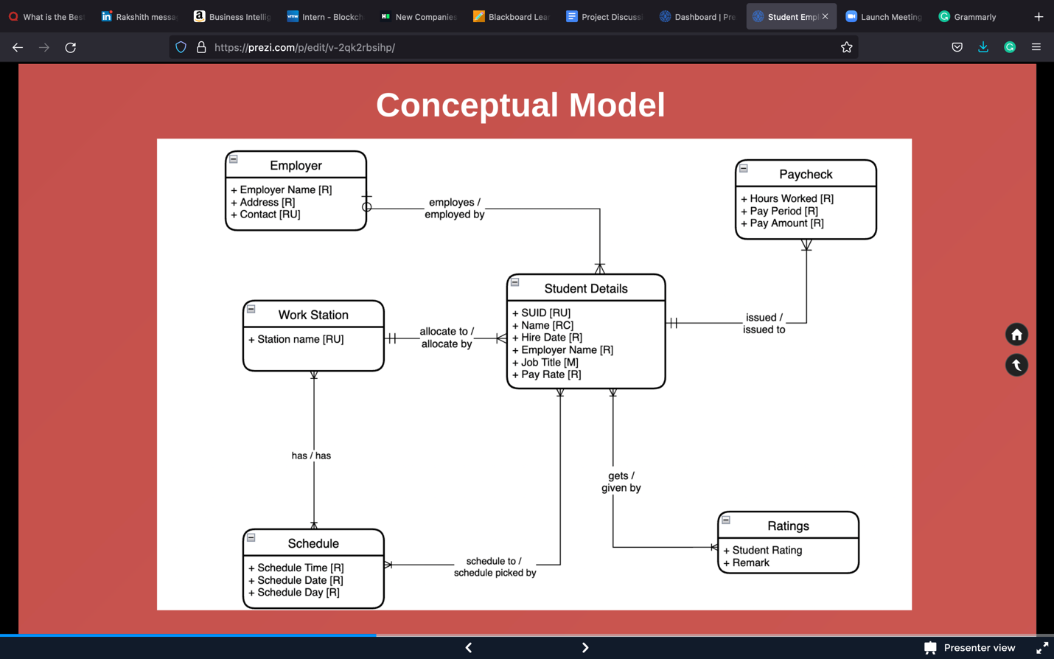

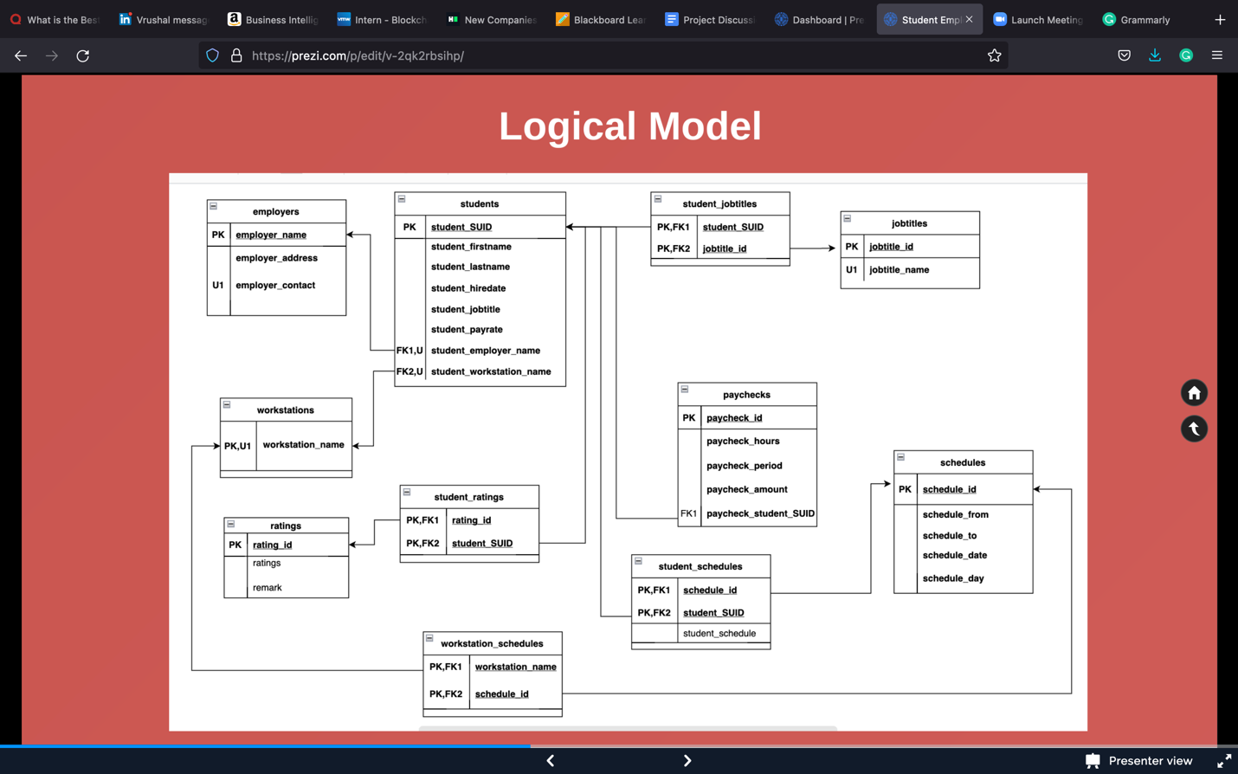

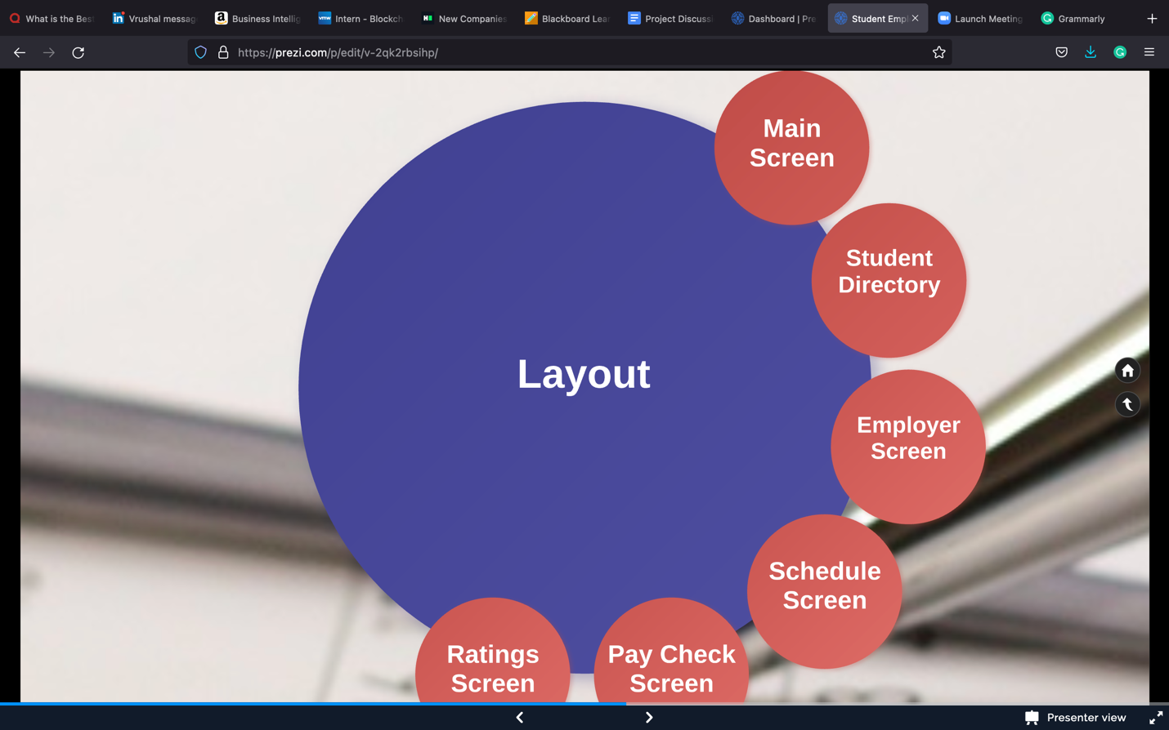

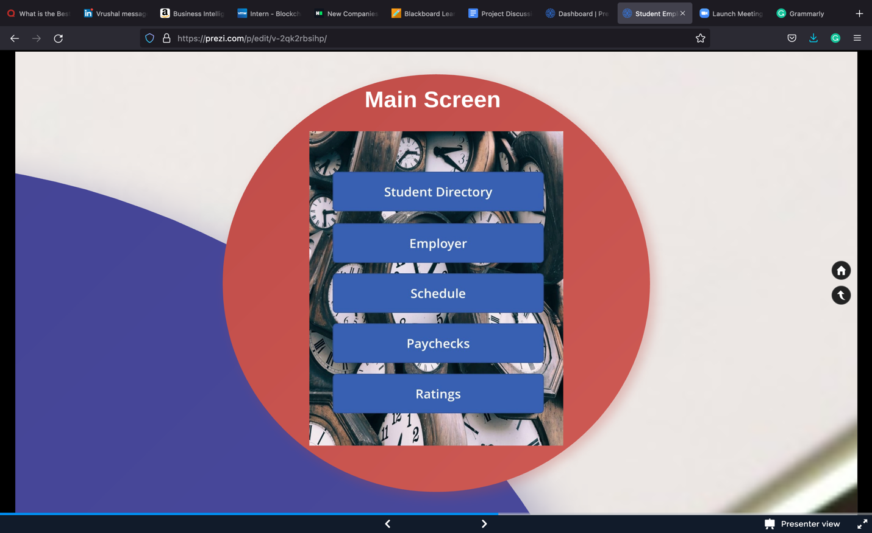

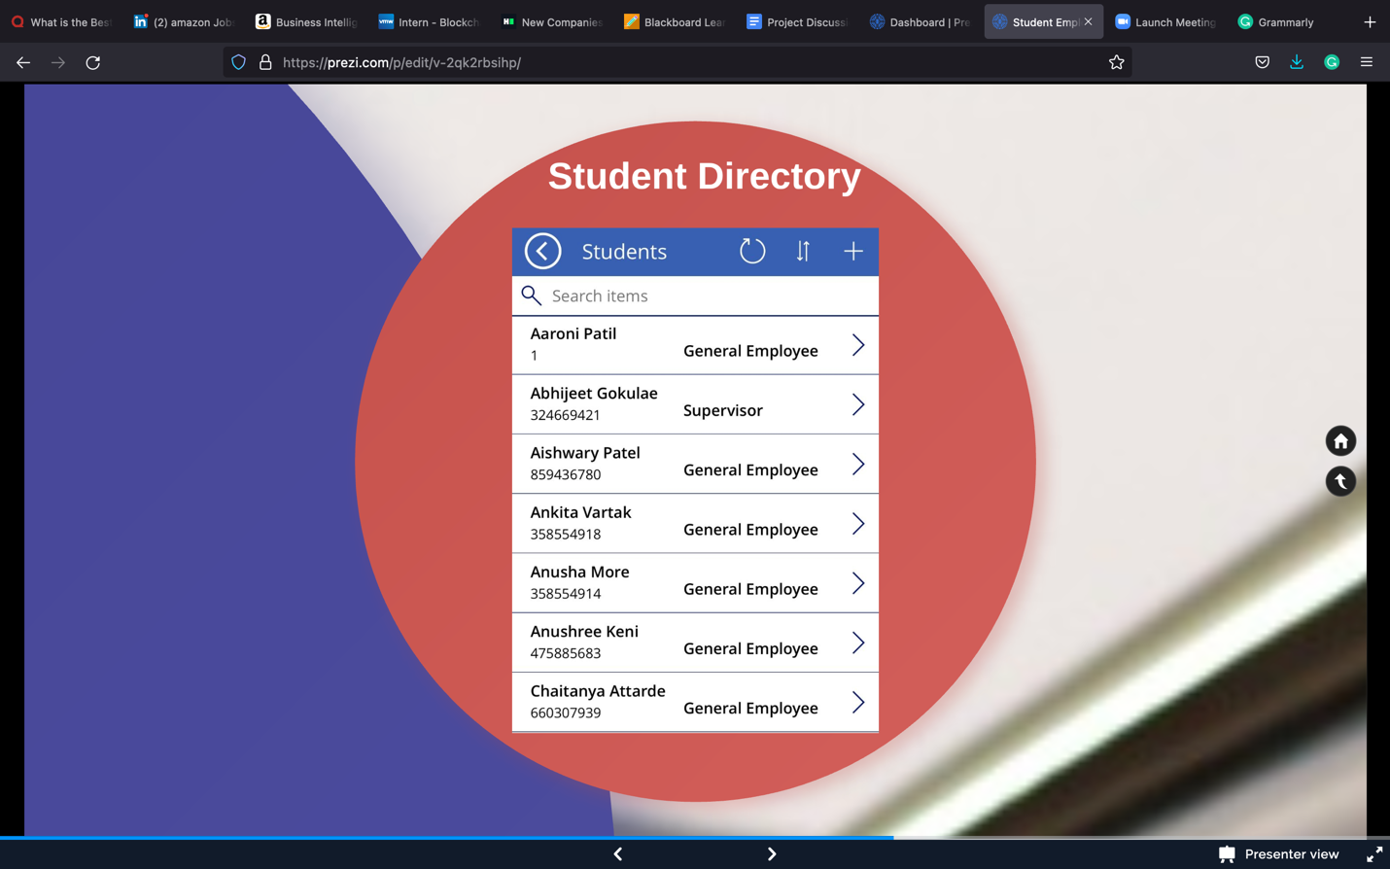

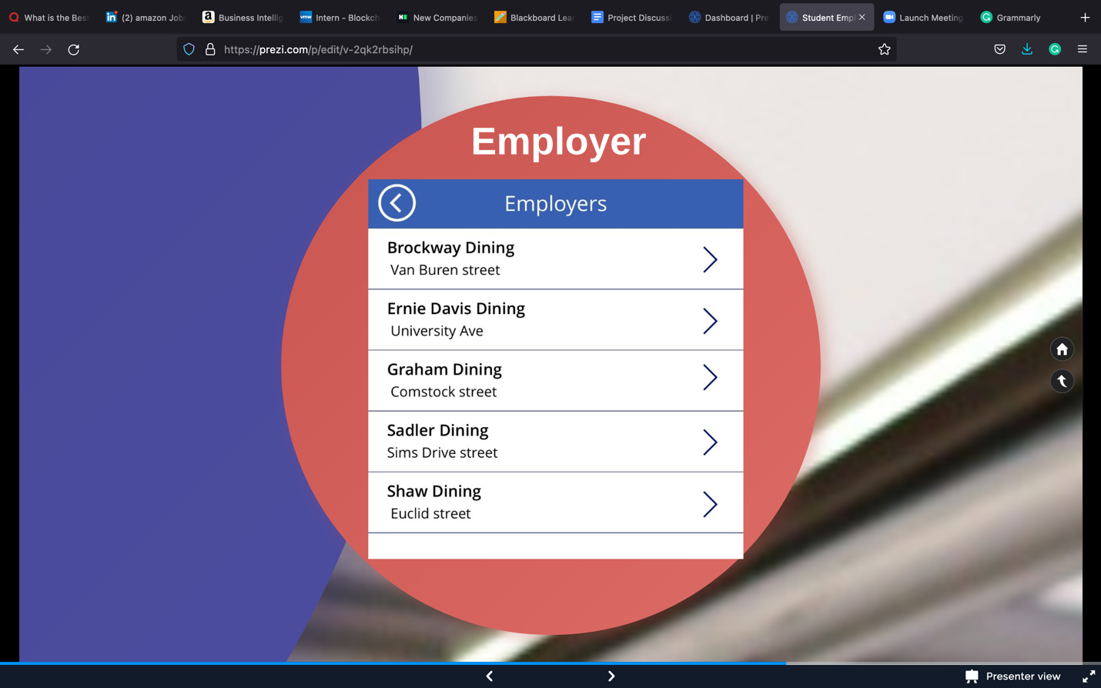

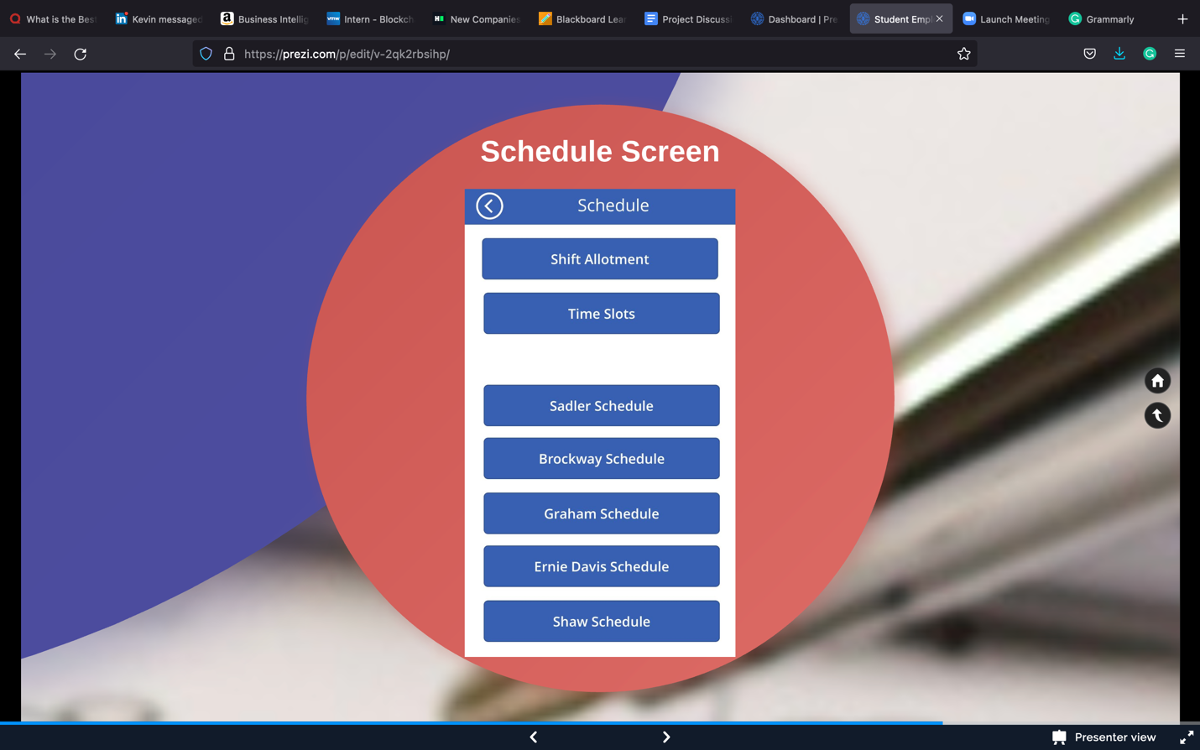

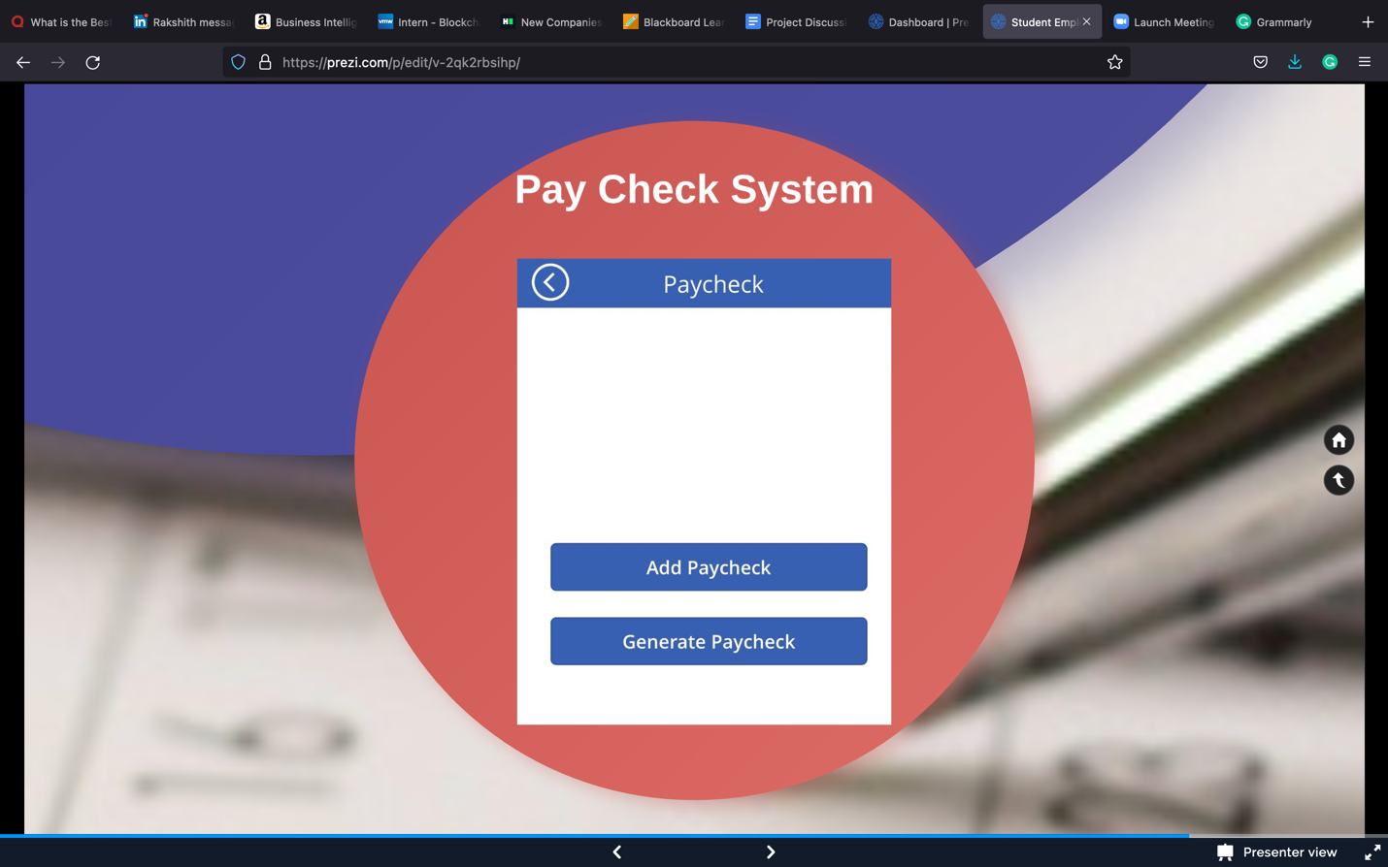

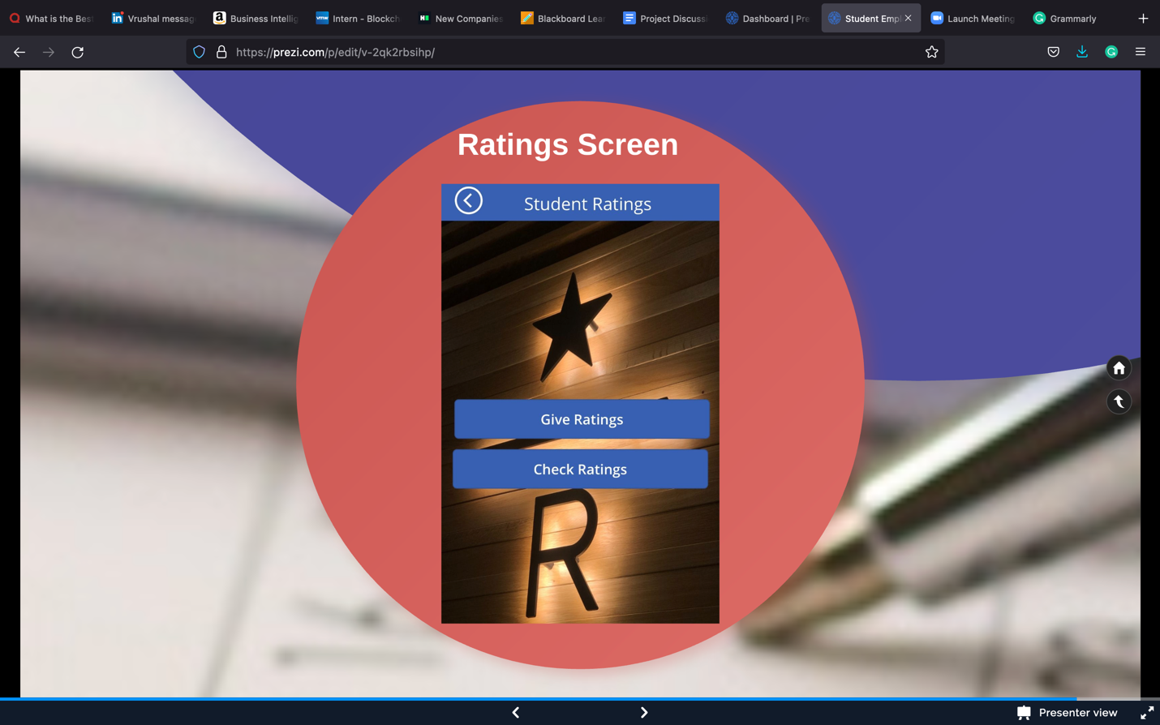

1. **Deliverables**

 

**Drive link to all the important project documents: -**

**https://drive.google.com/drive/folders/1wPNSEep9VZaWkeuaOIear1k3T1ggdOpI?usp=sharing**